Review Article Title
Author Name¹, Author Name², Author Name³…
ABSTRACT

Briefly outlines the background of the topic and highlights what makes it timely and worth reviewing, and summarises the specific goals or key messages of the review. The Abstract of a review article is typically structured as a single paragraph and doesn't include references. Abbreviations and heavy jargon should be kept to a minimum, but do include keywords that will optimise searchability. Typical number of words: 150–200.

INTRODUCTION

P
rovides more detailed background/contextual information to introduce the topic, including a basic description of key themes, terms and processes that will aid understanding of the rest of the article. The Introduction should also define the aims and scope of the article and briefly outline which subtopics will be discussed. This section should be written as continuous prose and should be supported with references, and figures (or other display items) if appropriate. Specific research findings would not usually be discussed in significant depth in the Introduction.
REVIEW
The central part of the review, which is usually divided into several subsections with appropriate topic-specific headings, should provide a detailed discussion of research findings relevant to the overall topic, with an adequate description of the methodologies, results and conclusions of individual research papers. Related research papers should be discussed together/under the same subheading, and these links should be made clear to readers to form a coherent narrative. Throughout, the significance of research findings in the broader context of the research topic being reviewed should be highlighted, and the author should aim to critically appraise the strengths and weaknesses of individual papers rather than just laying out facts. All subsections should be independently introduced and concluded, and the text should be fully supported with references. Care should be taken to cite the original article reporting a specific finding and the overall discussion should be balanced. Figures, tables and other display items should be used to aid understanding and break up long sections of text.
Figures and Tables
Place figure captions above the figures in 8pt regular font. If figure has two parts, include the labels “(A)” and “(B)” as part of the artwork.

Use the abbreviation “Fig.” even at the beginning of a sentence.

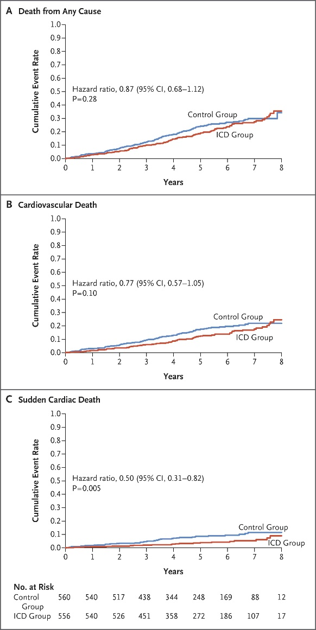

FIGURE 1. Example of the figure caption

Place table titles above the tables in 8pt regular font.

Please verify that the figures and tables you mention in the text actually exist.

If the size of Figure or Table is more than the column size, the same may be adjusted in single column format without disturbing rest of the content.

TABLE 1. Example of table styles

 | Table Column Head
 | Subhead | Subhead | Subhead
1
2
3
4
5
Other recommendations
- SI units are strongly encouraged.
- Use one space after periods and colons;
- Use a zero before decimal points: “0.25,” not “.25.”;
- Use “cm3,” not “cc.”;
- Indicate sample dimensions as “0.1 cm x 0.2 cm,” not “0.1 x 0.2 cm2.”
- Do not mix complete spellings and abbreviations of units: use “kg/m²” or “kilograms per square meter,” not “kilograms/m².”
- When expressing a range of values, write “2 to 7” or “2-7,” not “2~7.”
- A periods and commas must be within quotation marks, like “this period.” Other punctuation must be “outside”!
- Avoid contractions; for example, write “do not” instead of “don’t.”
- The serial comma is preferred: “A, B, and C” instead of “A, B and C.”
CONCLUSION
Rounds up the article by providing a summary of central themes and take-home messages. Can also provide the author's perspectives on future research in the field, key challenges and outstanding questions. Usually written as continuous prose but a bulleted list could be used to emphasize key points. Supporting references might be included.
AUTHOR AFFILIATION
A "byline" or "affiliation" is an acknowledgment of the organization that has supported you to conduct your research, and should be recorded on the published version of your output.
SUPPLEMENTARY MATERIALS
Supplementary material is relevant material that is additional to the main article. It can be anything from tables to presentations, to video and audio files.

These supplementary materials add another dimension to your article, and help with increasing its online reach and broadening the scope of its impact within your discipline.

Research shows that articles with supplementary material are downloaded and cited more often than those without. By including data and supporting materials to your article, researchers can access your work more easily. Funders are also able to identify clear links to data, making sure you meet your certain funding requirements.
Types of supplementary material
- Infographics - You can summarize your findings and attract readers to your article by including an infographic, alongside your article;
- Tables and charts - Include the full range of data and statistics from your research without over-cluttering your article;
- Video - Engage your audience and deliver the main points of your article across to your audience with multimedia;
- Audio - Consider adding relevant audio files to enhance your readers’ understanding and engagement with your research.
ACKNOWLEDGEMENTS
Mention all people who contributed substantially to the study but cannot be regarded as co-authors, and acknowledge all sources of funding. The recommended form is: “This work; was supported by the Medical Research Council [grant number xxxx]”. If no specific funding was provided, use the following sentence: “This research received no specific grant from any funding agency in the public, commercial, or not-for-profit sectors.” (RIN 2008). If relevant, disclose to the editors any other conflicts of interest, e.g., financial or personal links with the manufacturer or with an organization that has an interest in the submitted manuscript (Goozner et al 2009). If you reproduce previously published materials (e.g., figures), ask the copyright owners for permission and mention them in the captions or in the acknowledgements. If you were helped by a language professional (e.g., author’s editor or translator), a statistician, data collectors, etc., you should acknowledge their assistance for the sake of transparency (ICMJE 2017, Battisti et al 2015). It must be clear that they are not responsible for the final version of the article. You need to ensure you have the consent of all the people named in this section.
REFERENCES
Make sure that you have provided sources for all information extracted from other publications. In the list of references, include all data necessary to find them in a library or in the Internet. For non-English publications, give the original title (transliterated according to English rules if necessary), wherever possible followed by its translation into English in square brackets (CSE 2014). Avoid citing inaccessible, coercive and irrelevant references. Wherever appropriate, cite primary research articles instead of reviews (DORA 2013). Do not include unpublished data in the list of references – if you must mention them, describe their source in the main body of the article, and obtain permission from the producer of the data to cite them.

The American Medical Association (AMA) citation style is strongly encouraged.
AMA in-text citation
Example: As suggested by Nandita,1 carpal tunnel syndrome can also result from …
AMA book citation
Format: Author last name Initials. Book Title: Subtitle. Publisher; Year.
Example:
- Conrad P, Gallagher EB. Health and Health Care in Developing Countries: Sociological Perspectives. Temple University Press; 1993.
AMA journal citation
Format: Author last name Initials. Article title. Journal Name. Year;Volume(Issue):Page range. DOI or URL.
Example:
- Conrad P, Gallagher EB. Health and Health Care in Developing Countries: Sociological Perspectives. Temple University Press; 1993.
AMA website citation
Format: Author last name Initials. Page title. Website Name. Published Month Day, Year. Accessed Month Day, Year. URL.
Example:
- Murphy B. 5 tips to survive first-year anatomy lessons in medical school. American Medical Association. Published August 24, 2022. Accessed September 2, 2022. https://www.ama-assn.org/medical-students/medical-school-life/5-tips-survive-first-year-anatomy-lessons-medical-school.

